Get It 4 Me
- Please go to library.ollusa.edu
- Hover over Library Services on the blue ribbon and click Get It 4 Me. If you do not see anything on the blue ribbon, there will be a box with 3 or 4 lines and you will need to open this in order to find Library Services. This box appears when the mobile version is being used. 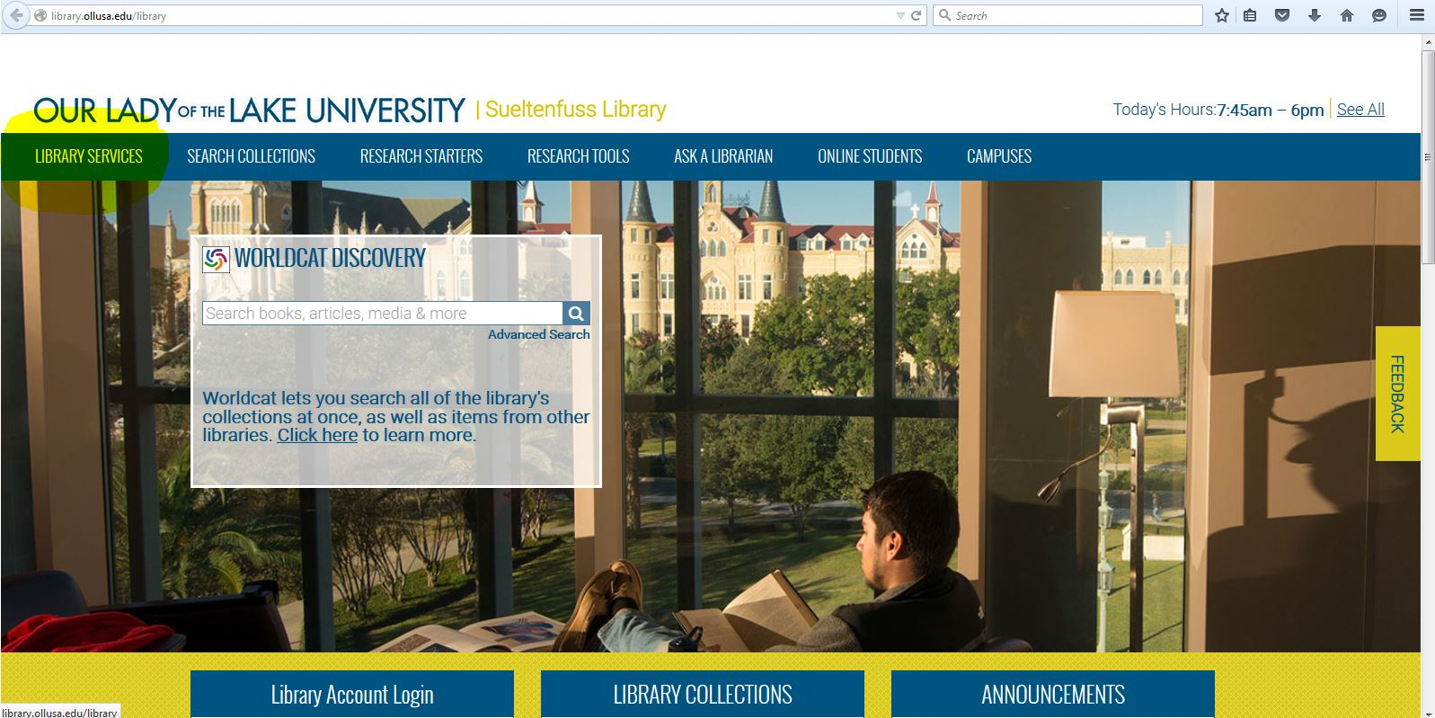
- After clicking on Get It 4 Me, you will see the screen below. Click on Get It 4 me Login Page.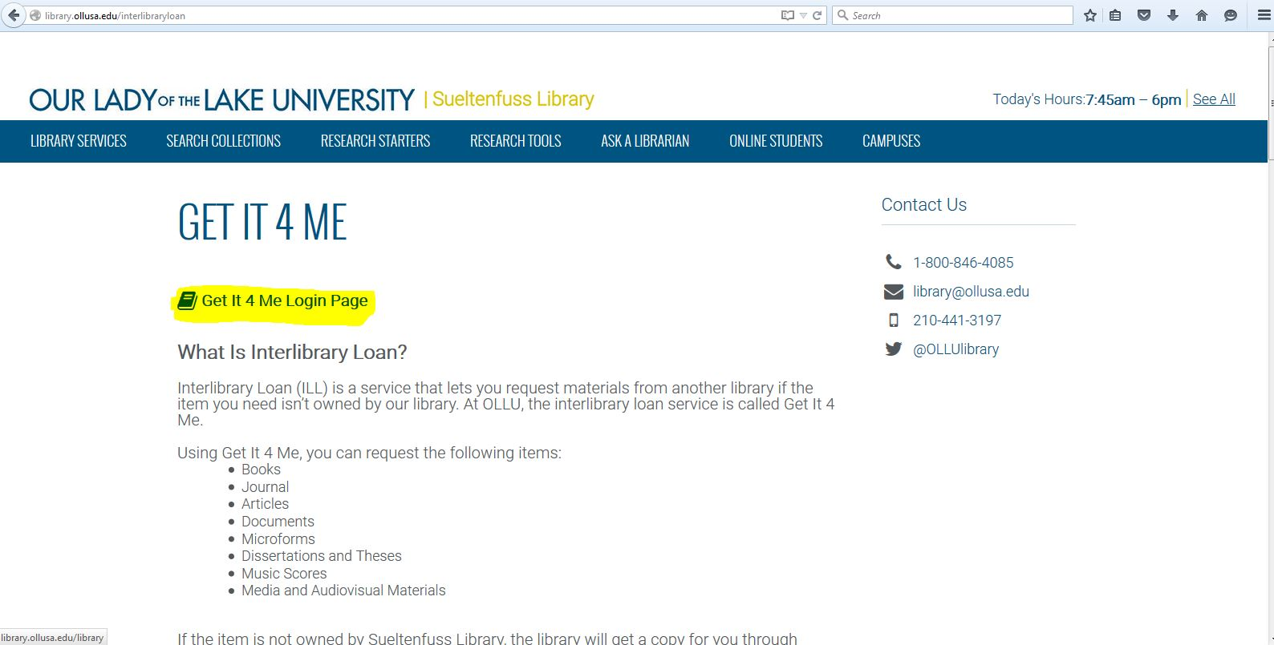
- Use the same login as myOLLU to log into Get It 4 Me. If this is your first time logging in you will need to fill out basic information so the library staff knows where to send your materials. Be sure to click on Logon otherwise it may say name is not found in database. 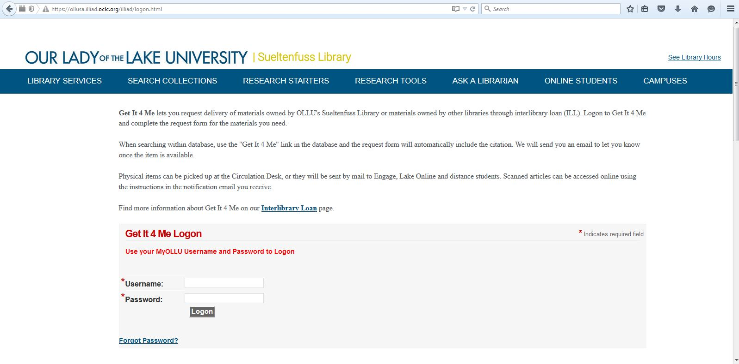
- If you are requesting an article click on Photocopy, under New Request, and type in the information that is needed, the more information provided the better. Once the article is received, you will get an email that the article is available. When you receive this email log back into Get It 4 Me and select Electronically Received Articles and you will have your article in PDF. 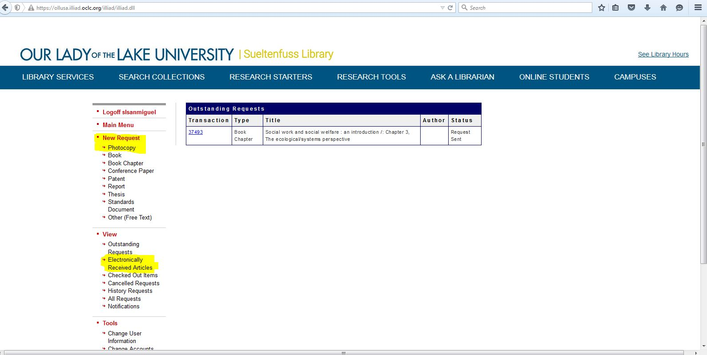

Please note articles will take at least a week, sometimes sooner to be received. Books will take at least 2 weeks because it is mailed to the university and then mailed to the address you have provided. If you have any questions about Get It 4 Me or wish to check your status contact Vanessa Meador at (210)434-6711 ext. 2325 or email at vmmeador@ollusa.edu.

